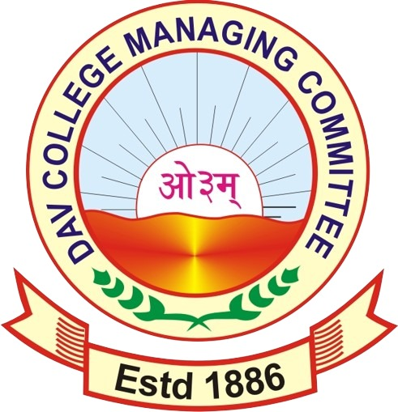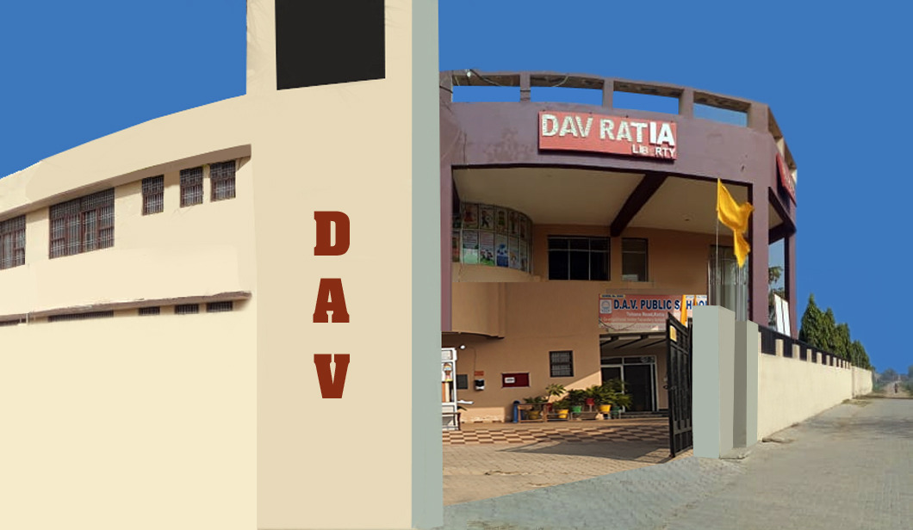

Name of The School : D.A.V. PUBLIC SCHOOL,RATIA
Address : Tohana Road ,Nathwan, Ratia Dist. Fatehabad
Email : davratia@rediffmail.com
Website : www.davratia.org
- Year of Establishment : 2007
- No. of Students as on 01.01.2024 : Boys: 1026 Girls : 591
: Total 1617
- Level of School : Senior Secondary
- Total No. of Staff : 85
- Teaching Staff : 70
- Non- Teaching Staff : 15
- Library
- Number of Books : 6538
- Journals & Magazine : 6
- Any Other : 3 News Papers
- Achievements
- Academic 2022-23 (Topper at 10+2 Level only) (Mention Overall top 05 scorers only)

Sr. No. | Name of Student | Board | Stream | Percentage of Marks
1 | SHVETA RANI | CBSE | COMMERCE | 95 %
2 | RADHIKA | CBSE | COMMERCE | 93.8%
3 | SANIA MONGA | CBSE | COMMERCE | 93.6 %
4 | JASHANDEEP KAUR | CBSE | SCIENCE | 93.2%
5 | DAMINI | CBSE | SCIENCE | 91%

- Academic 2023-24 (Topper at 10TH Level only) (Mention Overall top 05 scorers only)

Sr. No. | Name of Student | Board | Percentage of Marks
1 | GAGANDEEP | CBSE | 94.2 %
2 | VANSHIKA | CBSE | 93.2 %
3 | TANISHA | CBSE | 92.8 %
4 | ISHIKA GOYAL | CBSE | 92 %
5 | ARYAN BANSAL | CBSE | 91.8%

Name / Team | Event | Level State / Natio nal / International | Agency / Organiz By | Achievement  (Gold/Silver/Bronze
SAHIBDIL | PISTOL  SHOOTING | NATIONAL | SHOOTING FEDERATION OF INDIA | GOLD MEDAL
LOKESH | U-19 NATIONAL LEVEL G/R WRESTLING 72 KG | NATIONAL | SCHOOL GAMES FEDERATION OF INDIA | PARTICIPATION
MAYANK | KARATE CHAMPIONSHIP | DISTT. LEVEL | HARYANA SCHOOL GAMES | WON 1ST POSITION & GOLD MEDAL & PARTICIPATION IN STATE TOURNAMENT
KHUSHDEEP KAUR | 3000 M WALK | 12TH UNDER 20 ATHLETICS CHAMPIONSHIP | HARYANA ATHLETICS ASSOCIATION) | WON GOLD MEDAL
SAHIBDIL | PISTOL  SHOOTING  ( 25 MTR) | NATIONAL | NATIONAL RIFLE  SHOOTING | GOT 25th PLACE  AND WAS SELECTED FOR AKHIL BHARTIY SHOOTING  CHAMPIONSHIP
ARMAAN SIDHU | PISTOL SHOOTING | DISTT.  LEVEL | HARAYAN SCHOOL GAMES | WON GOLD MEDAL & WILL PARTICIPATE IN STATE
GURDIKSHA & HUSANDEEP KAUR | PISTOL SHOOTING | DISTT . LEVEL | HARAYAN SCHOOL GAMES | WON GOLD MEDAL & WILL PARTICIPATE IN STATE
PARNEET KAUR | SHOTPUT | DISTT.  LEVEL | HARAYAN SCHOOL GAMES | GOLD MEDAL
GURNOOR GINII | 3000 MTR  WALK | STATE  LEVEL | HARAYAN SCHOOL GAMES | GOLD MEDAL
KHUSHDEEP KAUR | 3000 MTR  WALK | STATE  LEVEL | HARAYAN SCHOOL GAMES | SILVER MEDAL
SAHAJBIR | U-19 G/R WRESTLING 97 KG. | STATE  LEVEL | HARAYAN SCHOOL GAMES | BRONZE MEDAL
AISHA | TAEKAWANDO | STATE LEVEL | HARAYAN SCHOOL GAMES | BRONZE MEDAL
KHUSHDEEP KAUR | HAMMER THROW | DISTT.  LEVEL | HARAYAN SCHOOL GAMES | GOLD MEDAL
MANISHA | DISCUSS THROW | DISTT . LEVEL | HARAYAN SCHOOL GAMES | GOLD MEDAL
GURNOOR GINNI | HAMMER THROW | DISTT . LEVEL | HARAYAN SCHOOL GAMES | GOLD MEDAL
SAHIBDIL | SHOOTING | NATIONAL | SGFI | GOLD MEDAL IN TEAM AND SILVER IN INDIVIDUAL GAME
MAYANK | KARATE CHAMPIONSHIP | DAV NATIONAL | DAV | SILVER MEDAL
PARN GOYAL | KARATE CHAMPIONHIP | NATIONAL | DAV | BRONZE MEDAL
KARTIK | WRESTLING | DAV NATIONAL | DAV | SILVER MEDAL
SAHAJVEER SINGH | WRESTLING | NATIONAL | SAFI | SILVER MEDAL
- Sports /Games (2023-24)

CO- curricular Activities (2023-24)

Name/  Team | Event | Agency/organized  By | Achievement  (Gold/Silver/Bronz e
BHUMIKA | THALI  DECORATION | BAL BHAWAN | FIRST POSITION
PARTIGYA  KRISH | QUIZ | BAL BHAWAN | FIRST PRIZE
MAAFI | RANGOLI  COMPETITION | BAL BHAWAN | FIRST PRIZE
NISHA RANI | SLOGAN WRITING | LEGEL LITRACY PROGRAM | 3RD PRIZE
MAAFI | PAINTING | GOVT. GIRLS SENIOR SECONDARY SCHOOL | 3RD PRIZE
BANZEER | SCIENCE SEMINAR | BLOCK LEVEL | 2ND PRIZE
RAMNEET KAUR  JASLEEN KAUR  SIMARJEET KAUR | SCIENCE QUIZ | DISTT LEVEL | 2ND PRIZE
YUVIKA  GARISHA  MUSKAN  BANITA  BHAVIKA  JEENU  RAVNEET | PATRIOTIC GROUP SONG  COMPETITION | BAL BHAWAN | 3RD PRIZE

ANNUAL REPORT SUBMITTED BY :

MONICA KHANNA
PRINCIPAL
D.A.V.PUBLIC SCHOOL
RATIA

